40.41: a) 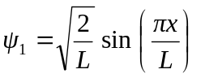
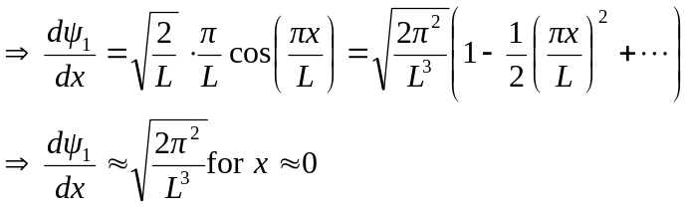
b) 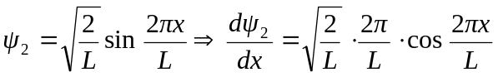
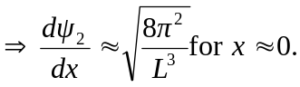
c) For 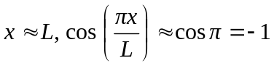
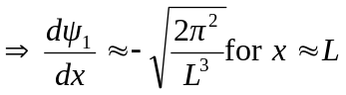
d) 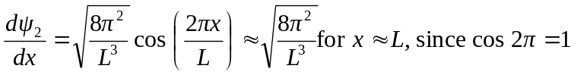
e) The slope of the wave function is greatest for 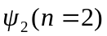 close to the walls of the box, as shown in Fig. 40.5.

